Global Design Document

**Version 1.0**

**February 25, 2020**

**Electric Blender**

**PO2_EBL**

**By: Mostafa Ramadan**

**Status: Draft**

**Document Status:**

|  |  |  |  |
| --- | --- | --- | --- |
| Version | Status | Author | Date |
| 1.0 | **Draft** | **Mostafa Ramadan** | **25 – 02 - 2020** |

**Document History:**

|  |  |  |  |
| --- | --- | --- | --- |
| Version | Author | Date | Change Description |
| 1.0 | **Mostafa Ramadan** | **25-02-2020** | **Adding document status and document history table** |
| 1.0 | **Mostafa Ramadan** | **27-02-2020** | **Adding the Static architecture & s/w sequence diagram** |
| 1.0 | **Fatima Gomaa** | **27-02-2020** | **Adding the s/w context diagram** |
| 1.0 | **Mostafa Ramadan** | **28-02-2020** | **Adding the Public APIs for the software** |
| 1.0 | **Mostafa Ramadan** | **02-03-2020** | **Adding all of the public APIs for the software** |

**Reference Table:**

|  |  |  |
| --- | --- | --- |
| Document | Version | Author |
| SRS | **1.6** | **Mostafa Ramadan** |
| CYRS | **1.4** | **Mohamed Anis & Fatima Gomaa** |

**Table Of Contents**

Table of Contents v

Table of Figures vi

1.0. Introduction 5

1.1.Purpose 5

2.0 Software Feature Diagram …….………………………5  
3.0 Static Architecture..……………………………………6  
4.0 Software Sequence Diagram...…………………………7  
5.0 Public APIs…………………………………………….8  
 5.1 Button Component……………………………………8

5.2 Switch Component……………………………………9

5.3 Delay Component……..………………………………10

5.4 Timer Component………………………..……………11

5.5 Blender Component…………………………..….……12

5.6 Motor Component………………………………..……14

5.7 PWM Component…………………………………..…16

5.8 Voltage Analyzer Component…………………………18

5.9 Voltage Shifter Component……………………………19

5.10 ADC Component……………………………………..20

**Table of Figures**

Figure 1 – Software Feature Diagram 5

Figure 2 – Static Architecture 6

Figure 3 – Software Sequence diagram 7

1. ***Introduction***
   1. ***Purpose***

The purpose of this document is to present the flow of the software through the system and shows the APIs that will cover the functionality of the software. And how the software shall act and react against certain parameters.

This document will explain the features of the system from the functional software manner.

1. ***Software Feature Diagram***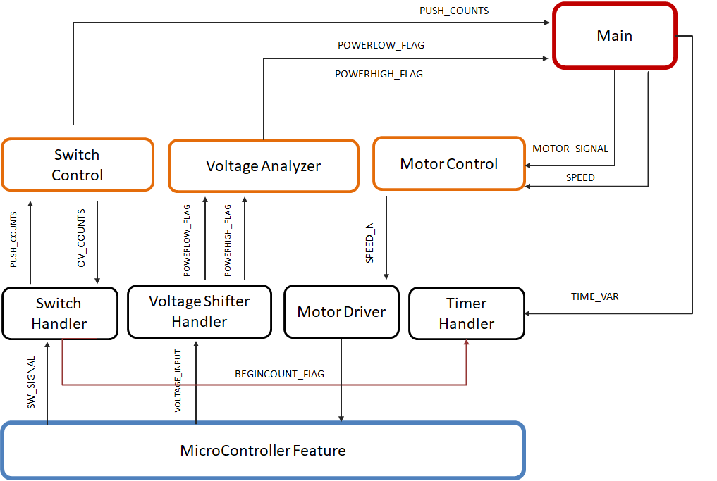
2. ***Static Architecture***
3. ***Software Sequence Diagram***

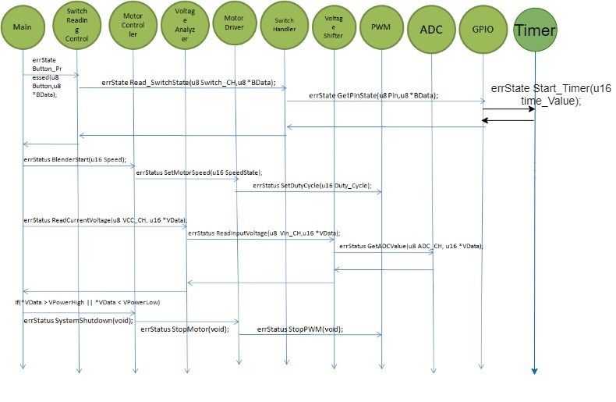

1. ***Public APIs***
   1. *Button Component*

|  |  |  |  |
| --- | --- | --- | --- |
| **Req_ID** | Req_ PO2_EBL_Electric_Blender_GDD_001-1.0 | **Covers** | Covers_ PO2_EBL_Electric_Blender_SRS_001-1.0 |
| **Author** | Mostafa Ramadan | **DATE** | 28/2/2020 |
| **API** | errState Button_Pressed(u8 Button_CH, u8 *BData); | | |
| **Description** | This Function shall read if the button is pressed or not. | | |
| **Inputs** | u8 Switch_CH, u8 *Data | **Outputs** | errStatus |

* 1. Switch Component

|  |  |  |  |
| --- | --- | --- | --- |
| **Req_ID** | Req_ PO2_EBL_Electric_Blender_GDD_002-1.0 | **Covers** | Covers_ PO2_EBL_Electric_Blender_SRS_001-1.0 |
| **Author** | Mostafa Ramadan | **DATE** | 28/2/2020 |
| **API** | errState Read_SwitchState(u8 Switch_CH, u8 *BData); | | |
| **Description** | This Function shall get the status of the Switch and return an error status in case it met the required functionality or not. | | |
| **Inputs** | u8 Switch_CH, u8 *Data | **Outputs** | errStatus |

* 1. Delay Component

|  |  |  |  |
| --- | --- | --- | --- |
| **Req_ID** | Req_ PO2_EBL_Electric_Blender_GDD_003-1.0 | **Covers** | Req_ PO2_EBL_Electric_Blender_SRS_012-1.5 & Req_ PO2_EBL_Electric_Blender_SRS_013-1.5 & Req_ PO2_EBL_Electric_Blender_SRS_015-1.5 |
| **Author** | Mostafa Ramadan | **DATE** | 2/3/2020 |
| **API** | errState delay_ms(u16 time_Value); | | |
| **Description** | This Function shall set the delay value for the system to know the time period of the button press | | |
| **Inputs** | U16 time_Value : value = 200ms | **Outputs** | errStatus |

* 1. Timer Component

|  |  |  |  |
| --- | --- | --- | --- |
| **Req_ID** | Req_ PO2_EBL_Electric_Blender_GDD_004-1.0 | **Covers** | Req_ PO2_EBL_Electric_Blender_SRS_002-1.5 & Req_ PO2_EBL_Electric_Blender_SRS_014-1.5 |
| **Author** | Mostafa Ramadan | **DATE** | 2/3/2020 |
| **API** | errState Start_Timer(u16 time_Value); | | |
| **Description** | This Function shall start the timer as soon as the button is pressed to calculate the time the button is pressed | | |
| **Inputs** | U16 time_Value : value = 200ms | **Outputs** | errStatus |

* 1. Blender Component

|  |  |  |  |
| --- | --- | --- | --- |
| **Req_ID** | Req_ PO2_EBL_Electric_Blender_GDD_005-1.0 | **Covers** | Req_ PO2_EBL_Electric_Blender_SRS_006-1.4 |
| **Author** | Mostafa Ramadan | **DATE** | 2/3/2020 |
| **API** | errState BlenderStart(u16 speed); | | |
| **Description** | This Function shall control the blender motor speed | | |
| **Inputs** | u16 speed: value range:   1. Speed 1 = 30% 2. Speed 2 = 60% 3. Speed 3 = 100% 4. Speed 4 = 0% | **Outputs** | errStatus |

|  |  |  |  |  |  |
| --- | --- | --- | --- | --- | --- |
| **Req_ID** | Req_ PO2_EBL_Electric_Blender_GDD_006-1.0 | **Covers** | Req_ PO2_EBL_Electric_Blender_SRS_009-1.4 & Req_ PO2_EBL_Electric_Blender_SRS_011-1.5 | | |
| **Author** | Mostafa Ramadan | **DATE** | 2/3/2020 | | |
| **API** | errState SystemShutdown(void); | | | | |
| **Description** | This Function shall shutdown the blender if there is voltage error to the system | | | | |
| **Inputs** | n/a | | | **Outputs** | errStatus |

* 1. Motor Component

|  |  |  |  |  |  |
| --- | --- | --- | --- | --- | --- |
| **Req_ID** | Req_ PO2_EBL_Electric_Blender_GDD_007-1.0 | **Covers** | Req_ PO2_EBL_Electric_Blender_SRS_005-1.4 | | |
| **Author** | Mostafa Ramadan | **DATE** | 2/3/2020 | | |
| **API** | errState SetMotorSpeed(u16 SpeedState); | | | | |
| **Description** | This Function shall control the duty cycle of PWM to feed the motor speed | | | | |
| **Inputs** | u16 SpeedState: value range:  SPEED_1 🡺 from 0% up to 30% of the duty cycle.  SPEED_2 🡺 from 30% up to 60% of the duty cycle  SPEED_3 🡺 from 60% up to 100% of the duty cycle | | | **Outputs** | errStatus |

|  |  |  |  |  |  |
| --- | --- | --- | --- | --- | --- |
| **Req_ID** | Req_ PO2_EBL_Electric_Blender_GDD_008-1.0 | **Covers** | Req_ PO2_EBL_Electric_Blender_SRS_009-1.4 & Req_ PO2_EBL_Electric_Blender_SRS_011-1.5 | | |
| **Author** | Mostafa Ramadan | **DATE** | 2/3/2020 | | |
| **API** | errState StopMotor(void); | | | | |
| **Description** | This Function shall stop the motor of the blender | | | | |
| **Inputs** | n/a | | | **Outputs** | errStatus |

* 1. PWM Component

|  |  |  |  |  |  |
| --- | --- | --- | --- | --- | --- |
| **Req_ID** | Req_ PO2_EBL_Electric_Blender_GDD_009-1.0 | **Covers** | Req_ PO2_EBL_Electric_Blender_SRS_005-1.4 | | |
| **Author** | Mostafa Ramadan | **DATE** | 2/3/2020 | | |
| **API** | errState SetDutyCycle(u16 Duty_Cycle); | | | | |
| **Description** | This Function shall Set the Duty Cycle of the PWM. | | | | |
| **Inputs** | u16 Duty_Cycle: value range:  SPEED_1 🡺 from 0% up to 30% of the duty cycle.  SPEED_2 🡺 from 30% up to 60% of the duty cycle  SPEED_3 🡺 from 60% up to 100% of the duty cycle | | | **Outputs** | errStatus |

|  |  |  |  |  |  |
| --- | --- | --- | --- | --- | --- |
| **Req_ID** | Req_ PO2_EBL_Electric_Blender_GDD_010-1.0 | **Covers** | Req_ PO2_EBL_Electric_Blender_SRS_009-1.4 & Req_ PO2_EBL_Electric_Blender_SRS_011-1.5 | | |
| **Author** | Mostafa Ramadan | **DATE** | 2/3/2020 | | |
| **API** | errState StopPWM(void); | | | | |
| **Description** | This Function shall shutdown the PWM peripheral. | | | | |
| **Inputs** | n/a | | | **Outputs** | errStatus |

* 1. Voltage Analyzer Component

|  |  |  |  |  |  |
| --- | --- | --- | --- | --- | --- |
| **Req_ID** | Req_ PO2_EBL_Electric_Blender_GDD_011-1.0 | **Covers** | Req_ PO2_EBL_Electric_Blender_SRS_008-1.5 & Req_ PO2_EBL_Electric_Blender_SRS_010-1.5 | | |
| **Author** | Mostafa Ramadan | **DATE** | 2/3/2020 | | |
| **API** | errState ReadCurrentVoltage(u8 VCC_CH,u16 *VData); | | | | |
| **Description** | This Function shall Read the input voltage to the blender | | | | |
| **Inputs** | U8 VCC_CH: the current voltage is connected to which channel  U16 * VData: the value of the current voltage applied to the system | | | **Outputs** | errStatus |

* 1. Voltage shifter Component

|  |  |  |  |  |  |
| --- | --- | --- | --- | --- | --- |
| **Req_ID** | Req_ PO2_EBL_Electric_Blender_GDD_012-1.0 | **Covers** | Req_ PO2_EBL_Electric_Blender_SRS_008-1.5 & Req_ PO2_EBL_Electric_Blender_SRS_010-1.5 | | |
| **Author** | Mostafa Ramadan | **DATE** | 2/3/2020 | | |
| **API** | errState ReadInputVoltage(u8 Vin_CH,u16 *VData); | | | | |
| **Description** | This Function shall Read the input voltage to the system | | | | |
| **Inputs** | U8 Vin_CH: the input voltage is connected to which channel  U16 * VData: the value of the current voltage applied to the system | | | **Outputs** | errStatus |

* 1. ADC Component

|  |  |  |  |  |  |
| --- | --- | --- | --- | --- | --- |
| **Req_ID** | Req_ PO2_EBL_Electric_Blender_GDD_013-1.0 | **Covers** | Req_ PO2_EBL_Electric_Blender_SRS_008-1.5 & Req_ PO2_EBL_Electric_Blender_SRS_010-1.5 | | |
| **Author** | Mostafa Ramadan | **DATE** | 2/3/2020 | | |
| **API** | errState GetADCValue(u8 ADC_CH,u16 *VData); | | | | |
| **Description** | This Function shall get the value applied to the ADC | | | | |
| **Inputs** | U8 ADC_CH: the input Signal is connected to which channel  U16 * VData: the value of the current Signal applied to the ADC | | | **Outputs** | errStatus |